SUB QUERY : To know about films which are having higher rate than avg rental rate Here it returns single value which means its ok to use =,>,< operators



Film id to be returned on this dates

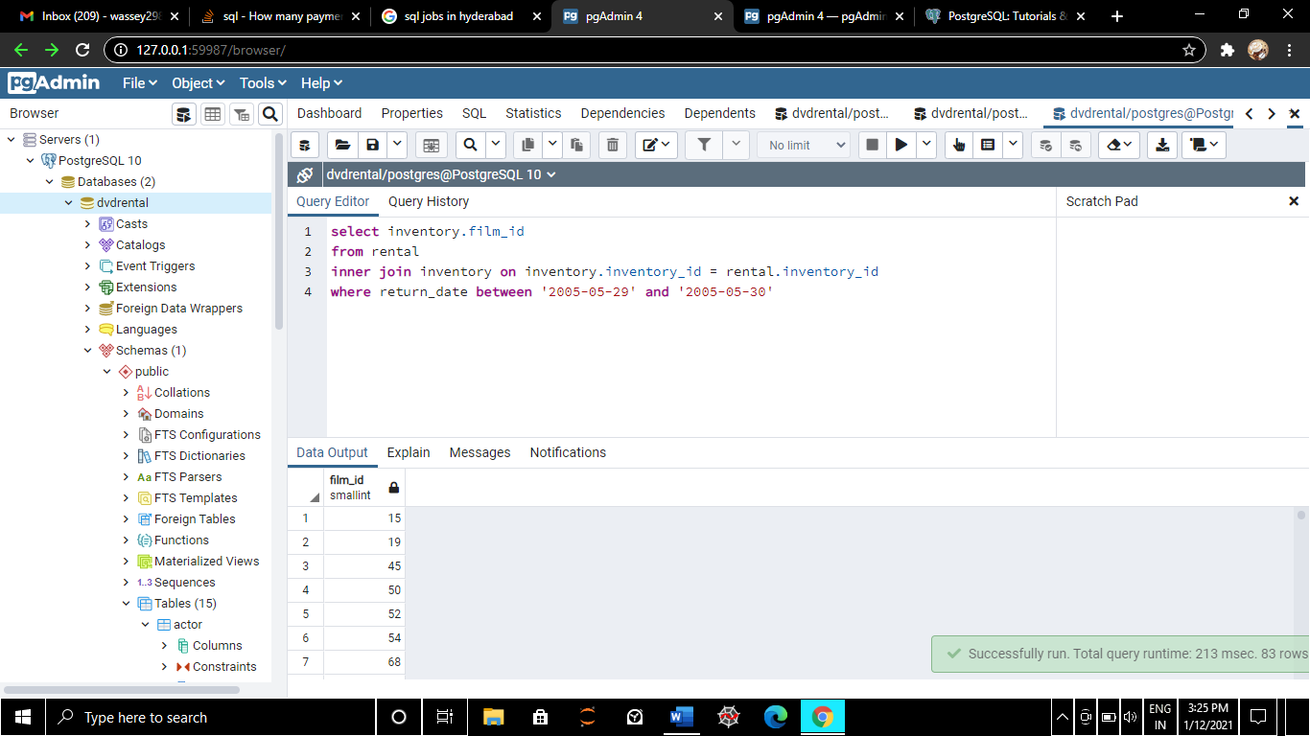

Let us imagine we need title of above film id, then this sol follows: If subquery returns back multiple value then you need to use the IN operator

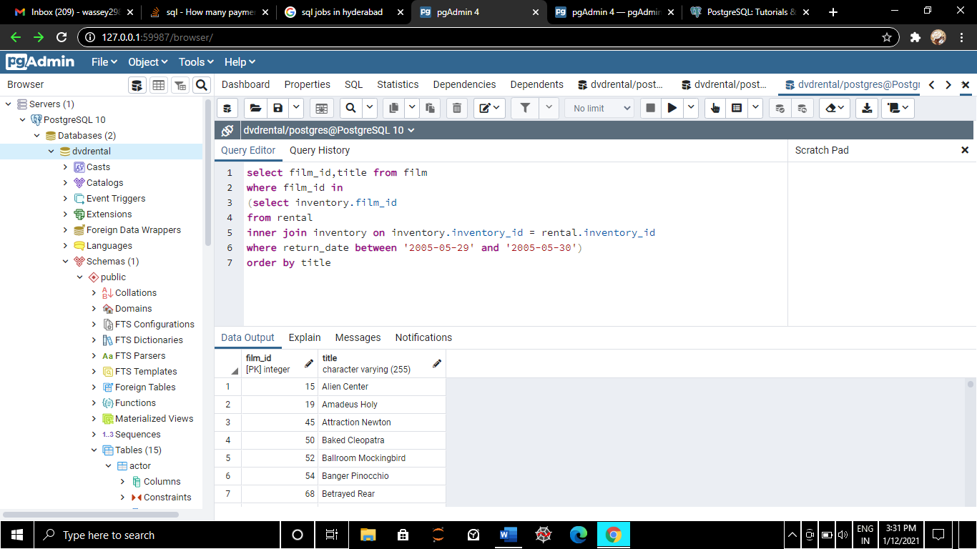

Now we use exists operator to know name of customer whose amount is greater than 11



Now we use exists operator to know name of customer whose amount is NOT greater than 11

